ASSIGNMENT 2B

Prediction and detection of epileptic seizures

Dániel Grimm – 2021163965

Anthony Laperche – 2021189749

1. Shallow neural network

The Shallow neural network has two layers, the first layer (29 inputs) used logsig as transfer function and the second used softmax. The training function is ‘trainscg’ (Scaled conjugate gradient) and the number of hidden layers is 140. With this neuronal network we have this result:

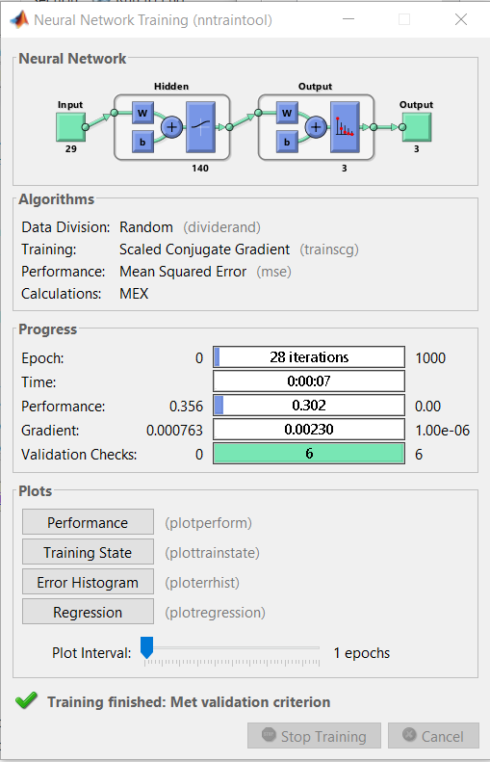

The performance of this neuronal Networks is quite bad.

1. Convolutional Neural Networks

The convolutional neural networks layers are setup like follow:

The neuronal networks used sgdm (stochastic gradient descent with momentum).

With this setup we have really good result :

1. Long Short Time Memory Neural Networks

The long short time memory neural networks layers are setup like follow:

With 3 classes, 29 features and 100 hiddenUnits the neuronal networks also used ‘adam’ as training option. With these layers we have this result:

1. GUI

If you want to test all the neuronal network, you just must lunch GUI then select the data and the neuronal network you and to use and after click on the action wanted.